Evolution by Natural Selection
Adapted from the University of California, Los Angeles Life Sciences 1 Demonstration Manual
Copyright 2013 by Drs. Jennifer Doherty and Ingrid Waldron, Department of Biology, University of Pennsylvania
Modified October 2013 by J. Feathers, M.Ed; Charter Oak High School

Simulation of Natural Selection

We will now play a simulation game to demonstrate how natural selection works. A simulation is a good way to mimic and simplify the process so we can observe how evolution by natural selection may work in a real population. This simulation involves tribbles that can reproduce. These tribbles live out their lives on a Black Forest or Red Grassland habitat in the classroom. The only concern our tribble creatures have is the presence of ravenous hunters (that’s you!).

The simulation will have the three necessary conditions for evolution by natural selection.
- Variation in characteristics: For natural selection to occur, different individuals in a population must have different characteristics. In our simulation, tribbles vary in color; they are black or red. The hunters vary as well; hunters have two distinct types of feeding structures: forks and spoons.
- Differences in fitness: For natural selection to occur, the different characteristics of different individuals must contribute to differences in fitness (i.e. differences in ability to survive and reproduce). For example, variation in tribble color may influence the probability that a tribble is snatched up by a hungry hunter. Also, different feeding structures may vary in their success in capturing tribbles. These differences contribute to survival and therefore success in reproducing.
- Heritability of characteristics: For natural selection to occur, the characteristics that affect fitness must be heritable (i.e. passed by genes from one generation to the next). In our simulation, a tribble that is born into the tribble population is the same color as its parent and a hunter that is born into the hunter population has the same feeding structure as its parent.

Here is what you will do:

- Your class will be split into groups which will carry out the simulation on two different habitats: Black Forest and Red Grassland.

- Tribbles come in two colors: black and red. Your teacher will scatter an equal number of each color on the Black Forest and on the Red Grassland. Which color tribble do you think will be more likely to survive in each habitat?

Black Forest:

Red Grassland:

Why do you think that?

- There are two different types of feeding structures: forks and spoons. Your teacher will distribute these feeding structures so that half the hunters in each habitat have forks and half have spoons. Complete the first and second rows of this table for the hunters in your habitat.

Hunters in ___________________________ Habitat | Spoon | Fork
Generation 1 - Number who have this feeding structure
Generation 2 - Number who have this feeding structure
Generation 3 - Number who have this feeding structure

You will also be given a cup. This cup will serve as your “stomach”. To capture a tribble, you must use only your fork or spoon to lift the tribble from the habitat and put it into your cup. Which feeding structure do you think will do better in each habitat?

Black Forest:

Red Grassland:

Why do you think that?

- At your teacher’s signal, start feeding. Don’t be shy about competing with your fellow hunters. However, once a tribble is on a fork or spoon it is off limits. When your teacher calls time, STOP feeding.

- Now count how many tribbles you have eaten and line up with your classmates who were feeding on the same habitat, from fewest tribbles eaten to most tribbles eaten. The hunters with the fewest pom-poms did not eat enough to survive; if you are in the bottom half of the number of pom-poms in your group, return your feeding structure to indicate that you have died. Each hunter who died will be reborn as the child of a hunter in the top half of the group who ate enough to survive and reproduce. Each child will receive the same feeding structure as his/her parent. After each hunter who died has been reborn, record the results in the generation 2 line of the above table.

- Your teacher will record how many tribbles of each color were eaten, calculate how many tribbles survived, and help the surviving tribbles reproduce. Only the tribbles that were not eaten will reproduce.

- While your teacher is busy preparing for the next round of feeding, discuss the following questions with your group:
- Which feeding structure contributed to greater fitness (ability to survive and reproduce)?
- ________________________________________________________________________________________________________________________________________________________________________________________________________________________________________________________________________________

- What characteristics of forks and spoons increased or decreased fitness?

- ________________________________________________________________________________________________________________________________________________________________________________________________________________________________________________________________________________

- You will run through the simulation one more time. Complete the last row in the table on page 3.

- Propose an explanation for any changes in the number of spoon vs. fork feeding structures from generation 1 to generation 3.

10. Your teacher will post on the board the numbers of tribbles of each color and hunters of each type at the beginning of the simulation (generation 1) and at the end of each cycle (generations 2 and 3). Copy these numbers in the table below. Then, for each generation of tribbles in each habitat, calculate the percent that are black or red. Similarly, for each generation of hunters in each habitat, calculate the percent that have spoons or forks as their feeding implement.
 | Black Forest
 | Tribbles |  |  | Hunters
 | Black | Red | Total | Spoon | Fork | Total
Generation 1
Number
Percent |  |  | 100% |  |  | 100%
Generation 2
Number
Percent |  |  | 100% |  |  | 100%
Generation 3
Number
Percent |  |  | 100% |  |  | 100%

 | Red Grassland
 | Tribbles |  |  | Hunters
 | Black | Red | Total | Spoon | Fork | Total
Generation 1
Number
Percent |  |  | 100% |  |  | 100%
Generation 2
Number
Percent |  |  | 100% |  |  | 100%
Generation 3
Number
Percent |  |  | 100% |  |  | 100%

11. Use the data to complete the following bar graphs. This will help you to see the trends in the percent of tribbles of each color and hunters with each type of feeding implement over the three generations in each habitat.

Tribbles in the Black Forest
100

50

0
Percent of tribbles

Color of tribbles | Black | Red |  | Black | Red |  | Black | Red
Generation | 1 2 3

Tribbles in the Red Grassland
100

50

0
Percent of tribbles

Color of tribbles | Black | Red |  | Black | Red |  | Black | Red
Generation | 1 2 3

Hunters in the Black Forest
100

50

0
Percent of hunters

Type of hunters | Spoon | Fork |  | Spoon | Fork |  | Spoon | Fork
Generation | 1 2 3

Hunters in the Red Grassland
100

50

0
Percent of hunters

Type of hunters | Spoon | Fork |  | Spoon | Fork |  | Spoon | Fork
Generation | 1 2 3

Questions
1. Did evolution by natural selection occur in each tribble population? In other words, did one tribble color become more common over time while the other color became less common?

Black Forest:

Red Grassland:

What traits contributed to the survival of tribbles that survived to reproduce?

Remember that the tribble populations were the same on the Black Forest and Red Grassland at the beginning. Explain why the trends differ in these two different habitats and the two populations of tribbles end up so different.

2. Did any individual tribbles change color or adapt? If not, then why did the colors of the tribbles in the final population differ from the colors of the tribbles in the original populations?

3. For each population of hunters, did one type of feeding structure become more common while the other type of feeding structure became less common? Explain the reasons for any trends in the type of feeding structure.

Black Forest:

Red Grassland:

Explain the reasons for any differences in trends between the two habitats.

4. If we ran the simulation for 50 more generations, what would you predict about the colors of the tribbles in each habitat?

Black Forest:

Red Grassland:

5. What do you think would happen to the tribble population if the black forest experienced a prolonged drought so all the trees died and the habitat became red grassland? First, make your prediction of what would happen if the population of tribbles in the black forest at the beginning of the drought included both red and black tribbles.

Next, suppose that natural selection over many generations had resulted in only black tribbles surviving in the black forest, and then a prolonged drought resulted in this habitat turning into a red grassland. Would natural selection for tribble color occur? Why or why not?
Based on this example, explain why evolution by natural selection can not occur if there is no variation in a characteristic.

6. Suppose that all the hunters in the simulation were blind-folded and could only find tribbles by touch. Would you expect evolution by natural selection in the color of the tribbles? Why or why not?

Explain why evolution by natural selection can not occur if the variation in a characteristic does not contribute to differences in fitness.

7. The following example illustrates a more complete definition of fitness as the ability to survive and produce offspring who can also survive and reproduce. According to this definition of him fitness, which of the four male lions described below would biologists consider the “fittest”?

Name | George | Dwayne | Spot | Tyrone
Age at death | 13 years | 16 years | 12 years | 10 years
# cubs fathered | 19 | 25 | 22 | 22
# cubs surviving to adulthood | 15 | 14 | 14 | 19
Size | 10 feet | 8.5 feet | 9 feet | 9 feet
(Adapted from Michigan State University, Occasional Paper No. 91, Evolution by Natural Selection: A Teaching Module by Beth Bishop and Charles Anderson, 1986)

Explain why Dwayne was not the fittest even though he lived the longest and fathered the most cubs.

Complete the following table.
If the reason why more of Tyrone's cubs survived was: | Would the offspring of Tyrone's cubs inherit characteristics that increased their chances of surviving to adulthood?  Explain why or why not.
Tyrone had heritable characteristics that increased resistance to infections, and many of his cubs inherited these characteristics.

Tyrone happened to live near a farmer whose children liked watching lion cubs, so for ten years the farmer put out meat with antibiotics for Tyrone's cubs.

Use this example to explain why natural selection does not operate on a characteristic which affects fitness but is not heritable.

8. This series of pictures shows natural selection in a population of cacti. Pictures 1 and 2 show what happened when a deer came to eat, picture 3 shows the cacti a few weeks later (notice the flowers on the right-hand cactus), and picture 4 shows the situation a few months later.
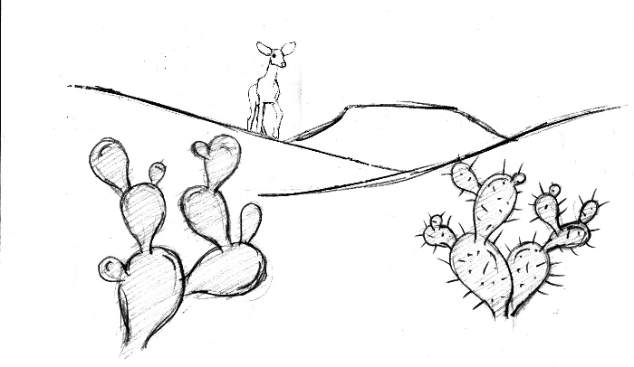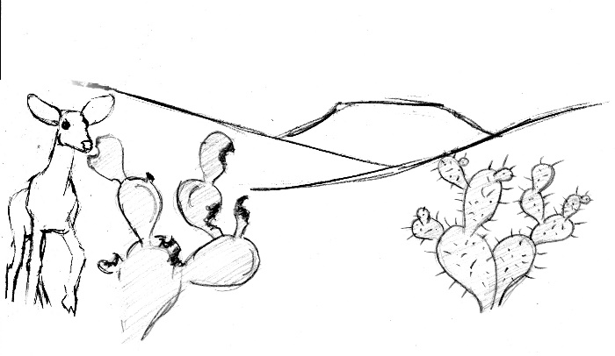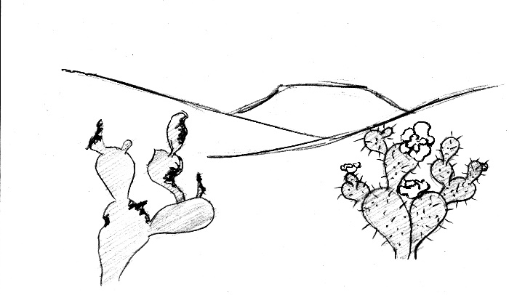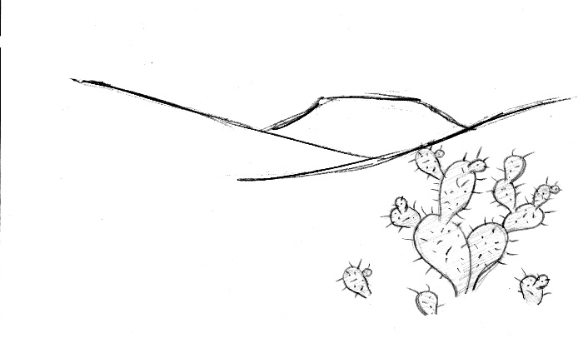
4
3
2
1

Complete the following table to describe how this cactus example illustrates the three necessary conditions for evolution by natural selection.
Necessary Condition for  Evolution by Natural Selection | How does the cactus example  illustrate this condition?

9. "Survival of the fittest" is a common expression. What do you think most people mean by this expression?

How would you explain this expression to help someone understand how natural selection actually functions?

